高通 display 驱动【转】
233333发表于linux驱动个人学习
2K

在这篇文章中：
- 0. 关键字
- 1. 涉及文件
- 3.时序图
- 4. 重要结构
  - 4.1 结构关系
- 5.结构赋值
- 6.lk中传递lcm使用的dsi配置名字给kernel
  - 6.1 dts中command格式解析
- 7. fb旋转参数配置
  - 7.1 方法1
  - 7.2 方法2
  - 7.3 方法三
- 8.展频
- 9. bklt_en_gpio、 disp_en_gpio、 rst_gpio相关gpio口
- 10. esd功能
  - 10.1 cmd mode demo
  - 10.2 video mode demo
高通display驱动

0. 关键字
MDSS : 高通平台lcd multimedia Display sub system DSI: Display Serial Interface
qcom,mdss-dsi-force-clock-lane-hs; // faulse ：clock每帧回lp11 ture: clock不回
qcom,mdss-dsi-hfp-power-mode; // data 每行回lp11,对应的hfp要修改成300以上

1. 涉及文件
- drivers\video\fbmem.c（核心层） register_framebuffer(struct fb_info *fb_info) //对外暴露核心函数
- drivers\video\msm\mdss\mdss_fb.c (mdss 核心层 fbx平台设备驱动) // 调用 fbmem.c的 register_framebuffer注册 fbx
- msm8909-mdss.dtsi（文件名通常为msm8909-mdss.dtsi指定了mdss的mdp和dsi） mdss_mdp: qcom,mdss_mdp@fd900000 { compatible = "qcom,mdss_mdp3"; // 对应mdss驱动 mdss_mdp. mdss_dsi0: qcom,mdss_dsi@fdd00000 { compatible = "qcom,msm-dsi-v2"; // 对应dsi解析驱动 dsi_host_v2.c
- drivers\video\msm\mdss\dsi_host_v2.c （lcd驱动 dsi） // 通过下面函数向 mdss_fb.c 注册了fb_info结构 (包含在mdss_dsi_ctrl_pdata结构中) dsi_panel_device_register_v2(struct platform_device *dev,struct mdss_dsi_ctrl_pdata *ctrl_pdata) static const struct of_device_id msm_dsi_v2_dt_match[] = { {.compatible = "qcom,msm-dsi-v2"}, {} }; 或者 drivers\video\msm\mdss\mdss_dsi.c
- drivers\video\msm\mdss\mdp3.c （mdp） .compatible = "qcom,mdss_mdp3",
- arch/arm/boot/dts/qcom/msm8909-qrd-skua.dtsi 通常在dts文件的 mdss_dsi0 lab里面通过qcom,dsi-pref-prim-pan 属性 指定使用哪一个lcd配置 &mdss_dsi0 { qcom,dsi-pref-prim-pan = <&dsi_hx8379a_fwvga_skua_vid>; pinctrl-names = "mdss_default", "mdss_sleep"; pinctrl-0 = <&mdss_dsi_active &mdss_te_active>; pinctrl-1 = <&mdss_dsi_suspend &mdss_te_suspend>; qcom,platform-reset-gpio = <&msm_gpio 25 0>; };
- dsi-panel-fl10802-fwvga-video.dtsi &mdss_mdp { dsi_fl10802_fwvga_vid: qcom,mdss_dsi_fl10802_fwvga_video { qcom,mdss-dsi-panel-name = "fl10802 fwvga video mode dsi panel"; qcom,mdss-dsi-drive-ic = "fl10802"; qcom,mdss-dsi-panel-controller = <&mdss_dsi0>; qcom,mdss-dsi-panel-type = "dsi_video_mode"; qcom,mdss-dsi-panel-destination = "display_1"; ... } 2. mdss_mdp 和 mdss_dsi0 的关系 mdss_mdp 相当于一个数组，里面定义了很多不同lcd显示屏的配置项包括分辨率等等
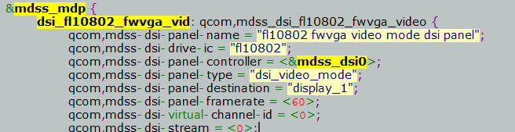
--- mdss_dsi0 的 “qcom,dsi-pref-prim-pan ” 属性指定了使用mdss_mdp中哪一个lcd配置选项
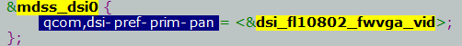

3.时序图
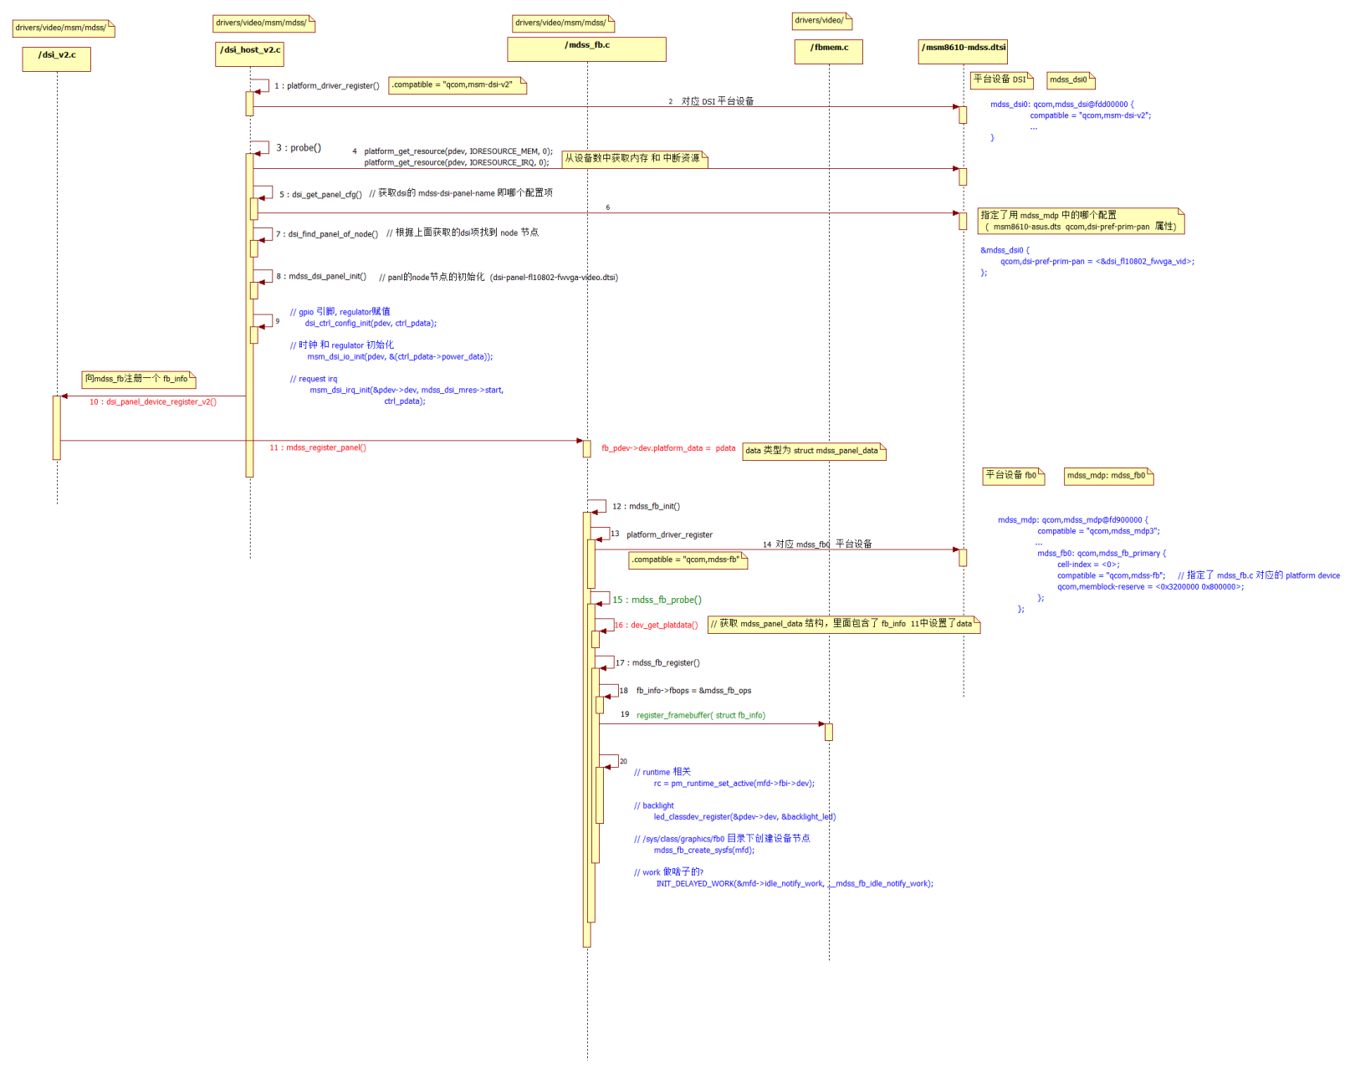

4. 重要结构

4.1 结构关系
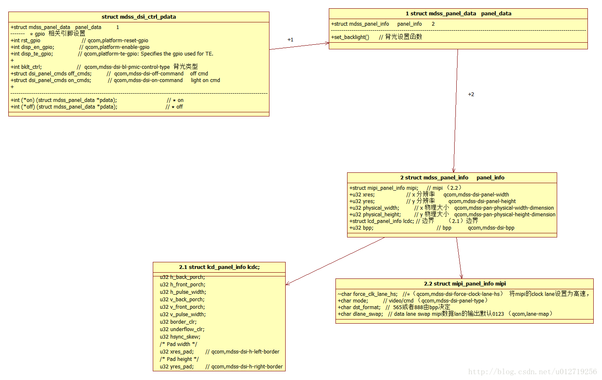
backLight
关键字：qcom,mdss-dsi-bl-pmic-control-type
struct mdss_dsi_ctrl_pdata {
int ndx; /* panel_num */
int (*on) (struct mdss_panel_data *pdata); // ★ on
int (*off) (struct mdss_panel_data *pdata); // ★ off
int (*partial_update_fnc) (struct mdss_panel_data *pdata);
int (*check_status) (struct mdss_dsi_ctrl_pdata *pdata);
int (*cmdlist_commit)(struct mdss_dsi_ctrl_pdata *ctrl, int from_mdp);
void (*switch_mode) (struct mdss_panel_data *pdata, int mode);
struct mdss_panel_data panel_data; //★ panel_data.set_backlight 设置背光亮度函数
//★ panel_data.panel_info = struct mdss_panel_info ①
unsigned char *ctrl_base;
struct dss_io_data ctrl_io;
struct dss_io_data mmss_misc_io;
struct dss_io_data phy_io;
int reg_size;
u32 bus_clk_cnt;
u32 link_clk_cnt;
u32 flags;
struct clk *mdp_core_clk;
struct clk *ahb_clk;
struct clk *axi_clk;
struct clk *mmss_misc_ahb_clk;
struct clk *byte_clk;
struct clk *esc_clk;
struct clk *pixel_clk;
u8 ctrl_state;
int panel_mode;
int irq_cnt;
int rst_gpio; // ★ gpio qcom,platform-reset-gpio: Specifies the panel reset gpio.
int disp_en_gpio; // qcom,platform-enable-gpio: Specifies the panel lcd/display enable gpio.
int disp_te_gpio; // qcom,platform-te-gpio: Specifies the gpio used for TE.
int mode_gpio; // qcom,platform-mode-gpio: Select video/command mode of panel through gpio when it supports both modes.
int disp_te_gpio_requested;
int bklt_ctrl; /* backlight ctrl 背光类型*/
int pwm_period;
int pwm_pmic_gpio;
int pwm_lpg_chan;
int bklt_max;
int new_fps;
int pwm_enabled;
bool dmap_iommu_map;
struct pwm_device *pwm_bl;
struct dsi_drv_cm_data shared_pdata;
u32 pclk_rate;
u32 byte_clk_rate;
struct dss_module_power power_data; // ★ clock & regulator
u32 dsi_irq_mask;
struct mdss_hw *dsi_hw;
struct mdss_panel_recovery *recovery;

struct dsi_panel_cmds on_cmds; // light on cmd ★ qcom,mdss-dsi-on-command

struct dsi_panel_cmds off_cmds; // off cmd ★ qcom,mdss-dsi-off-command
struct dsi_panel_cmds status_cmds;
u32 status_value;

struct dsi_panel_cmds video2cmd;
struct dsi_panel_cmds cmd2video;

struct dcs_cmd_list cmdlist;
struct completion dma_comp;
struct completion mdp_comp;
struct completion video_comp;
struct completion bta_comp;
spinlock_t irq_lock;
spinlock_t mdp_lock;
int mdp_busy;
struct mutex mutex;
struct mutex cmd_mutex;

bool ulps;

struct dsi_buf tx_buf;
struct dsi_buf rx_buf;
struct dsi_buf status_buf;
int status_mode;
};
struct mdss_panel_info结构体
struct mdss_panel_info {
u32 xres; // x 分辨率 qcom,mdss-dsi-panel-width
u32 yres; // y 分辨率 qcom,mdss-dsi-panel-height
u32 physical_width; // x 物理大小 qcom,mdss-pan-physical-width-dimension
u32 physical_height; // y 物理大小 qcom,mdss-pan-physical-height-dimension
struct lcd_panel_info lcdc; // 边界 （1.1）边界
u32 bpp; // bpp qcom,mdss-dsi-bpp
struct mipi_panel_info mipi; // mipi显示模式 video or cmd （1.2）mipi

u32 type;
u32 wait_cycle;
u32 pdest; // 第几个fb设备 qcom,mdss-dsi-panel-destination = "display_1";
u32 brightness_max;
u32 bl_max;
u32 bl_min;
u32 fb_num;
u32 clk_rate;
u32 clk_min;
u32 clk_max;
u32 frame_count;
u32 is_3d_panel;
u32 out_format;
u32 rst_seq[MDSS_DSI_RST_SEQ_LEN];
...
}
（1.1）边界
struct lcd_panel_info {
u32 h_back_porch;
u32 h_front_porch;
u32 h_pulse_width;
u32 v_back_porch;
u32 v_front_porch;
u32 v_pulse_width;
u32 border_clr;
u32 underflow_clr;
u32 hsync_skew;
/* Pad width */
u32 xres_pad; // qcom,mdss-dsi-h-left-border
/* Pad height */
u32 yres_pad; // qcom,mdss-dsi-h-right-border
};
（1.2）mipi
struct mipi_panel_info {
char mode; /* video/cmd */ // 显示模式 qcom,mdss-dsi-panel-type = "dsi_video_mode";
char interleave_mode;
char crc_check;
char ecc_check;
char dst_format; /* shared by video and command */
char data_lane0;
char data_lane1;
char data_lane2;
char data_lane3;
char dlane_swap; /* data lane swap */
char rgb_swap;
char b_sel;
char g_sel;
char r_sel;
char rx_eot_ignore;
char tx_eot_append;
char t_clk_post; /* 0xc0, DSI_CLKOUT_TIMING_CTRL */
char t_clk_pre; /* 0xc0, DSI_CLKOUT_TIMING_CTRL */
char vc; /* virtual channel */
struct mdss_dsi_phy_ctrl dsi_phy_db;
/* video mode */
char pulse_mode_hsa_he;
char hfp_power_stop;
char hbp_power_stop;
char hsa_power_stop;
char eof_bllp_power_stop;
char last_line_interleave_en;
char bllp_power_stop;
char traffic_mode;
char frame_rate;
/* command mode */
char interleave_max;
char insert_dcs_cmd;
char wr_mem_continue;
char wr_mem_start;
char te_sel;
char stream; /* 0 or 1 */
char mdp_trigger;
char dma_trigger;
/*Dynamic Switch Support*/
bool dynamic_switch_enabled;
u32 pixel_packing;
u32 dsi_pclk_rate;
/* The packet-size should not bet changed */
char no_max_pkt_size;
/* Clock required during LP commands */
char force_clk_lane_hs; //强制DSI_CLK始终处于HS，因我们用DSI CLK as 参考时钟

char vsync_enable;
char hw_vsync_mode;

char lp11_init;
u32 init_delay;
};

5.结构赋值
//结构从设备数中获取数据赋值 mdss_dsi_panel.c
int mdss_dsi_panel_init(struct device_node *node,struct mdss_dsi_ctrl_pdata *ctrl_pdata, int ndx)
// use
Dsi_host_v2.c (drivers\video\msm\mdss):
rc = mdss_dsi_panel_init(dsi_pan_node, ctrl_pdata, cmd_cfg_cont_splash);
Mdss_dsi.c (drivers\video\msm\mdss):
rc = mdss_dsi_panel_init(dsi_pan_node, ctrl_pdata, ndx);

6.lk中传递lcm使用的dsi配置名字给kernel
aboot_init // lk\app\aboot\aboot.c
target_display_init // lk\target\msm8953\target_display.c
gcdb_display_init // lk\dev\gcdb\display\gcdb_display.c
msm_display_init // display.c
display_image_on_screen //

aboot_init // lk\app\aboot\aboot.c
target_display_init // lk\target\msm8953\target_display.c
gcdb_display_init // lk\dev\gcdb\display\gcdb_display.c
oem_panel_select // lk\target\msm8953\oem_panel.c

panel_id = NT51021B_INX_WUXGA_VIDEO_PANEL; // ☆ panel_id 赋值，使用哪个lcd配置

init_panel_data

switch (panel_id) {
case NT51021B_INX_WUXGA_VIDEO_PANEL:
panelstruct->paneldata = &nt51021b_inx_wuxga_video_panel_data; // 根据 panel_id 指定传给kernel使用的lcm配置

----------
// lk\dev\gcdb\display\include\panel_nt51021b_inx_wuxga_video.h (lcm配置文件)

static struct panel_config nt51021b_inx_wuxga_video_panel_data = {
"qcom,mdss_dsi_nt51021b_inx_wuxga_video", // ☆ panel_node_id 对应dtsi中 panel使用的名字
"dsi:0:", "qcom,mdss-dsi-panel",
10, 0, "DISPLAY_1", 0, 0, 60, 0, 0, 0, 1, 10000, 0, 0, 0, 0, 0, 0, NULL
};
----------
// arch\arm64\boot\dts\qcom\dsi-panel-nt51021b-inx-wuxga-video.dtsi
&mdss_mdp {
dsi_nt51021b_inx_wuxga_vid: qcom,mdss_dsi_nt51021b_inx_wuxga_video {//dts中的 panel名字
qcom,mdss-dsi-panel-name = "nt51021b inx wuxga video mode dsi panel"; /

6.1 dts中command格式解析
qcom,mdss-dsi-on-command = [
// 延时 reg data
29 01 00 00 01 00 02 8F A5
29 01 00 00 14 00 02 01 00
29 01 00 00 01 00 02 8F A5
29 01 00 00 00 00 02 8C 80
29 01 00 00 00 00 02 C7 50
29 01 00 00 00 00 02 C5 50
29 01 00 00 00 00 02 85 04
29 01 00 00 00 00 02 86 08
29 01 00 00 00 00 02 83 AA
29 01 00 00 00 00 02 84 11
29 01 00 00 00 00 02 A0 36
29 01 00 00 00 00 02 A1 36
29 01 00 00 00 00 02 9C 10
29 01 00 00 00 00 02 A9 4B
29 01 00 00 00 00 02 8F 00];

7. fb旋转参数配置

7.1 方法1
fb_info->var->rotate // 是否旋转

7.2 方法2
msm_fb_data_type->panel_orientation //是否旋转fb (mdss_fb.h)

// 通过dsi中的 qcom,mdss-dsi-panel-orientation 关键字控制 （mdss_dsi_panel.c）
data = of_get_property(np, "qcom,mdss-dsi-panel-orientation", NULL);
if (data) {
pr_debug("panel orientation is %s\n", data);
if (!strcmp(data, "180"))
pinfo->panel_orientation = MDP_ROT_180;
else if (!strcmp(data, "hflip"))
pinfo->panel_orientation = MDP_FLIP_LR;
else if (!strcmp(data, "vflip"))
pinfo->panel_orientation = MDP_FLIP_UD;
}

7.3 方法三
system/build.prop

8.展频
mdss-pll.c
展频开关：
arch/arm/boot/dts/qcom/msm8953-mdss-pll.dtsi qcom,dsi-pll-ssc-en;
mode：
qcom,dsi-pll-ssc-mode = "down-spread";

two parameters to program SSC ：

clk/msm/mdss/mdss-dsi-pll-8996.c:ssc_ppm_default & ssc_freq_default

展频范围：

down mode : freq - freq * (ssc_ppm/1000,000)

center mode : freq ± freq * (ssc_ppm/1000,000) / 2

up mode : freq + freq * (ssc_ppm/1000,000)

9. bklt_en_gpio、 disp_en_gpio、 rst_gpio相关gpio口
// (msm8917-pmi8937-qrd-sku5.dtsi board.dtsi ) mdss_dsi_active mdss_dsi_suspend qcom,platform-reset-gpio qcom,platform-enable-gpio
&mdss_dsi0 {
qcom,dsi-pref-prim-pan = <&dsi_hx8394f_720p_video>;
pinctrl-names = "mdss_default", "mdss_sleep";
pinctrl-0 = <&mdss_dsi_active>;
pinctrl-1 = <&mdss_dsi_suspend>;

qcom,platform-reset-gpio = <&tlmm 60 0>; // rst
qcom,platform-enable-gpio= <&tlmm 46 0>; //供电引脚
};

//(mdss_dsi.c) disp_en_gpio bklt_en_gpio rst_gpio
// mdss_dsi_parse_gpio_params
ctrl_pdata->disp_en_gpio = of_get_named_gpio(ctrl_pdev->dev.of_node,"qcom,platform-enable-gpio", 0);
ctrl_pdata->disp_te_gpio = of_get_named_gpio(ctrl_pdev->dev.of_node,"qcom,platform-te-gpio", 0);
ctrl_pdata->bklt_en_gpio = of_get_named_gpio(ctrl_pdev->dev.of_node,"qcom,platform-bklight-en-gpio", 0);
ctrl_pdata->rst_gpio = of_get_named_gpio(ctrl_pdev->dev.of_node,"qcom,platform-reset-gpio", 0);
ctrl_pdata->mode_gpio = of_get_named_gpio(ctrl_pdev->dev.of_node,"qcom,platform-mode-gpio", 0);

// mdss_dsi_panel_power_on
mdss_dsi_panel_reset(pdata, 1); // (mdss_dsi_panel.c)
gpio_set_value((ctrl_pdata->bklt_en_gpio), 0);
gpio_set_value((ctrl_pdata->disp_en_gpio), 0);
gpio_set_value((ctrl_pdata->rst_gpio), 0);

// mdss_dsi_panel_power_off
mdss_dsi_panel_reset(pdata, 0); // (mdss_dsi_panel.c)
gpio_set_value((ctrl_pdata->bklt_en_gpio), 0);
gpio_set_value((ctrl_pdata->disp_en_gpio), 0);
gpio_set_value((ctrl_pdata->rst_gpio), 0);
// (msm8917-pinctrl.dtsi)

pmx_mdss: pmx_mdss {
mdss_dsi_active: mdss_dsi_active {
mux {
pins = "gpio60", "gpio46";
function = "gpio";
};

config {
pins = "gpio60", "gpio46";
drive-strength = <8>; /* 8 mA */
bias-disable = <0>; /* no pull */
// output-high;
};
};
mdss_dsi_suspend: mdss_dsi_suspend {
mux {
pins = "gpio60", "gpio46";
function = "gpio";
};

config {
pins = "gpio60", "gpio46";
drive-strength = <2>; /* 2 mA */
bias-pull-down; /* pull down */
};
};

10. esd功能
qcom,esd-check-enabled // 是否使用esd check 功能
qcom,mdss-dsi-panel-status-check-mode // esd check的方式 te_signal_check （只能在cmd模式下用）or reg_read

10.1 cmd mode demo
qcom,mdss-dsi-te-pin-select = <1>;
qcom,mdss-dsi-te-v-sync-rd-ptr-irq-line = <0x2c>;
qcom,mdss-dsi-te-v-sync-continue-lines = <0x3c>;
qcom,mdss-dsi-te-dcs-command = <1>;
qcom,esd-check-enabled; // enable esd check
qcom,mdss-dsi-panel-status-check-mode = "te_signal_check"; // esd check mode te模式 (只能用作cmd模式)
qcom,mdss-dsi-te-check-enable; // te
qcom,mdss-dsi-te-using-te-pin; // use te pin

10.2 video mode demo
qcom,esd-check-enabled;
qcom,mdss-dsi-panel-status-check-mode = "reg_read";
qcom,mdss-dsi-panel-status-command = [06 01 00 01 05 00 02 0A 08];
qcom,mdss-dsi-panel-status-command-state = "dsi_lp_mode";
qcom,mdss-dsi-panel-status-read-length = <1>;
qcom,mdss-dsi-panel-max-error-count = <2>;
qcom,mdss-dsi-panel-status-value = <0x9c>;

